Nonprofit Org.

ECRWSS

U.S. POSTAGE

PAID

Permit No. 16

Cornell, WI

BOXHOLDER

HOLCOMBE

WISCONSIN 54745

P.O.Box 517

Cornell, WI 54732

Cornell & Lake Holcombe

**Community**

**Education**



FALL 2016

OFFERINGS

**Compliments of the**

**21st Century Community Learning Centers**

**of Cornell and Lake Holcombe**

**Access this brochure anytime, anywhere by visiting our website at** [**www.communitylc.weebly.com**](http://www.communitylc.weebly.com)

**Click on the Community Education tab**

**Welcome to the Cornell/Lake Holcombe**

**Community Education Fall 2016 Catalog. Enclosed within these pages is information about upcoming classes and community activities. Community Education is a cooperative venture between the Cornell/Lake Holcombe 21st Century CLC’s, the school districts, Rutledge Charities, and the City of Cornell. It is committed to providing services and programs to meet community needs and residents’ interests. So, take time to look over the brochure, sign up and**

***ADD A LITTLE “CLASS” TO YOUR LIFE!***

**Cornell and Lake Holcombe Community Education**

**P.O. Box 517 Cornell, WI 54732**

**Check out our website!**

**www.communitylc.weebly.com**

**HOW TO REGISTER**

**Walk-In or Mail-In**

You may register in person Complete the Registration Form.

for all Community Ed classes *Make checks payable to:

by stopping by the Community  **Cornell / LH Community Ed**

Learning Center at Cornell *Mail Registration to:

Elementary School or at **Community Education**

Lake Holcombe Schools **P.O. Box 517**

**Cornell, WI 54732**

**Please register at least 1 week prior to the start of the class.**

*No confirmation of registration will be sent. If class is cancelled because of low enrollment, you will be notified by phone and your money refunded. Once a class has begun, no refunds are permitted. Sorry, no refunds on trips.

**Need more info? Call Andrea Smith, Director**

**at (715)861-8011 or (715) 595-4241 ext. 249**

[**asmith@cornell.k12.wi.us**](mailto:asmith@cornell.k12.wi.us)

**Community Ed Registration Form**

**Name: ___________________________________________________________**

**Address: ________________________________________________________**

**Home Phone: ___________________ Cell Phone: _____________________**

**Email address: _______________________________________**

**C.E. Course Title(s):**

**1. _______________________________________________Fee: __________**

**2. _______________________________________________Fee: __________**

**3. _______________________________________________Fee: __________**

**___ Donate $5 to CLC Fund** (to help continue offering our programs) **__________**

**(Make checks payable to Cornell/LH Community Ed) Total: ____________**

**Community Ed Registration Form**

**Name: ___________________________________________________________**

**Address: ________________________________________________________**

**Home Phone: ___________________ Cell Phone: _____________________**

**Email address: _______________________________________**

**C.E. Course Title(s):**

**1. _______________________________________________Fee: __________**

**2. _______________________________________________Fee: __________**

**3. _______________________________________________Fee: __________**

**___ Donate $5 to CLC Fund** (to help continue offering our programs) **__________**

**(Make checks payable to Cornell/LH Community Ed) Total: ____________**

Special Event-Save the Date!



**Crafts**

**Mosaic Stepping Stones**

Construct a gorgeous mosaic stepping stone using stained glass. We’ll learn to cut and grind glass, nip glass pieces, and adhere to a 12”x12” concrete base. All materials will be supplied by instructor, Linda Bergen, who will also grout and seal the finished project. All materials are provided.

**Wednesday, October 12 9:00am-1:00pm**

**Fee: $45 Linda Bergen’s Home**

**Maine Potato Basket**

The base on this basket is woven in the Penobscot Tribe tradition, who inhabited the Penobscot Bay in Maine in the early 17th Century. It measures 16” in diameter and stands about the same height. It’s a very sturdy basket with an oak hoop for the rim and a strong oak handle. It’s not hard to weave but some previous experience is helpful. Shirley Mount, owner of the Basket Patch in Gilman, instructs. **Supplies to bring to class: Bucket, towel, clip clothes pins, pencil, tape measure, scissors, flat screwdriver.**

**Thursday, October 27 5:00-9:00pm**

**Fee: $45 Cornell Elementary School**

**Slumped Wine Bottle &**

**Wire Wrapped Serving Utensil**

Using silver para-wire and an assortment of glass beads, participants will learn wire wrapping techniques as they wrap the neck of a slumped (flattened or kiln) wine bottle and matching knife or spoon. These projects make a perfect holiday gift or keep it yourself! Two sessions are offered.

**Wednesday, November 16 9am-noon or 5:00-8:00pm**

**Fee: $25 Linda Bergen’s Home**

**Weaving-Oval Waste Basket**

This basket is the perfect size next to a desk or sewing machine, or in the bathroom. A plastic grocery bag fits inside nicely. It could also hold your craft projects and look beautiful at the same time! In this class you will learn to wrap your own handles, use overlays with dyed reed to accent (selection of color in class), and add the ball feet. It measures 13”x9”x15” tall, including the handles. This class is good for beginners as well as the experienced weaver. Shirley Mount, owner of the Basket Patch in Gilman, instructs.

**Supplies to bring to class: Bucket, towel, clip clothes pins, pencil, tape measure, scissors, flat screwdriver.**

**Thursday, December 1 5:00-9:00pm**

**Fee: $35 Cornell Elementary School**

**Stained Glass Mosaic Krafty Block**

Using a glass Krafty Block, we’ll create a mosaic on the block using stained glass pieces. A string of lights is inserted into the opening and when illuminated, it becomes a beautiful piece of artwork! All materials will be supplied by instructor, Linda Bergen.

**Wednesday, December 7 9am-noon or 5:00-8:00pm**

**Fee: $25 Linda Bergen’s Home**

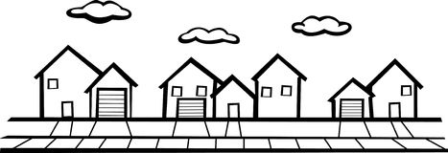

**Community**

**METH-Town Hall Meeting**

The Chippewa County Drug Endangered Children (DEC) Team is holding a forum on methamphetamine use and its implications on our community.

Meth use in the community has risen significantly and the number of children placed outside of their home in relation to meth use has increased from 10 in 2013 to 64 at present. This event is sponsored by multiple Chippewa County Law Enforcement agencies and Chippewa County Human Services.

**Join us and get to kNOw meth and what you can do to stop it.**

**Tuesday, October 11 6:00-7:30pm**

**Fee: FREE Cornell High School**

**Camaraderie Club**

The name says it all! This very friendly and active group of adults meets every Monday morning for coffee, conversation and camaraderie! Something new is offered each week including information on hot topics, craft activities, guest speakers, games, and cards. Small fees may be required for special events. Join us anytime…no membership required!

**Mondays 9:00-11:00am**

**Fee: FREE Cornell Elementary School**

**Sewing Group**

Are you new to sewing? Do you just want to spend time with others doing what

you love? A sewing group could be the perfect place for you. Enjoy a cup of

coffee and some conversation while working on your sewing projects in the company of other crafters. Share ideas and watch the progress of each

project from week to week.

**Wednesdays 9:00-11:00am**

**Fee: FREE Cornell Elementary School**

**Passport Fair**-Cornell Elementary School

**Thursday, November 10 10am-5:30pm**

**New Passport Book: Adults Good for 10 years**

Application Fee $110 (payment to: Department of State)

Execution Fee $25 (payment to US Postal Service)

Photo $15 (payment to US Postal Service)

Check, Money Order or Cash accepted. No credit cards! Cash payment will require an additional fee of $1.20.

**TWO SEPARATE CHECK/M.O’s are required; One to Dept of State, one to Post Office**

**Documentation required:**

**Bring all forms of payment along with you**

*Photo ID (Driver License)

*Original Birth Certificate with raised seal (not a hospital copy; must be State issued)

*2”x2” COLOR Passport Photo- These can be taken at the passport fair for a $15 fee.

You may provide your own photo but it is at the discretion of the Post Office. Walgreens and WalMart take Passport Photos

_________________________________________________________________________

**New Passport Book: Age 16-17 Good for 10 years**

Application Fee $110 (payment to: Department of State)

Execution Fee $25 (payment to US Postal Service)

Photo $15 (payment to US Postal Service)

**\*\*NOTE: At least ONE parent must accompany you and have evidence of parental relationship**Check, Money Order or Cash accepted. (see payment details above)

**Documentation required:**

*Photo ID (Driver License)

*Original Birth Certificate with raised seal (not a hospital copy; must be State issued)

*2”x2” COLOR Passport Photo-(see details above)

**________________________________________________________________________**

**New Passport Book: Under Age 16 Good for 5 years**

Application Fee $80 (payment to: Department of State)

Execution Fee $25 (payment to US Postal Service)

Photo $15 (payment to US Postal Service)

**\*\*NOTE: BOTH PARENTS must accompany you and have evidence of parental relationship**Check, Money Order or Cash accepted! (See payment details above)

**Documentation required:**

*Photo ID (Driver License)

*Original Birth Certificate with raised seal (not a hospital copy; must be State issued)

*2”x2” COLOR Passport Photo- (see details above)

To expedite processing at the Passport Fair, go to travel.state.gov and download form DS-11. Complete the form and bring it with you.

Note: Passport Cards are also available (see website). **Passport cards are only valid for driving across the border to Canada or Mexico and a few ports, to very limited Caribbean locations. They are NOT valid for air travel.**

Normal processing time is 6 weeks. There will be additional fees to expedite application. Expedited processing time is 3 weeks. **QUESTIONS?**

**Call Postmaster, Christina Petranovich at the Thorp Post Office at (715) 669-5766**

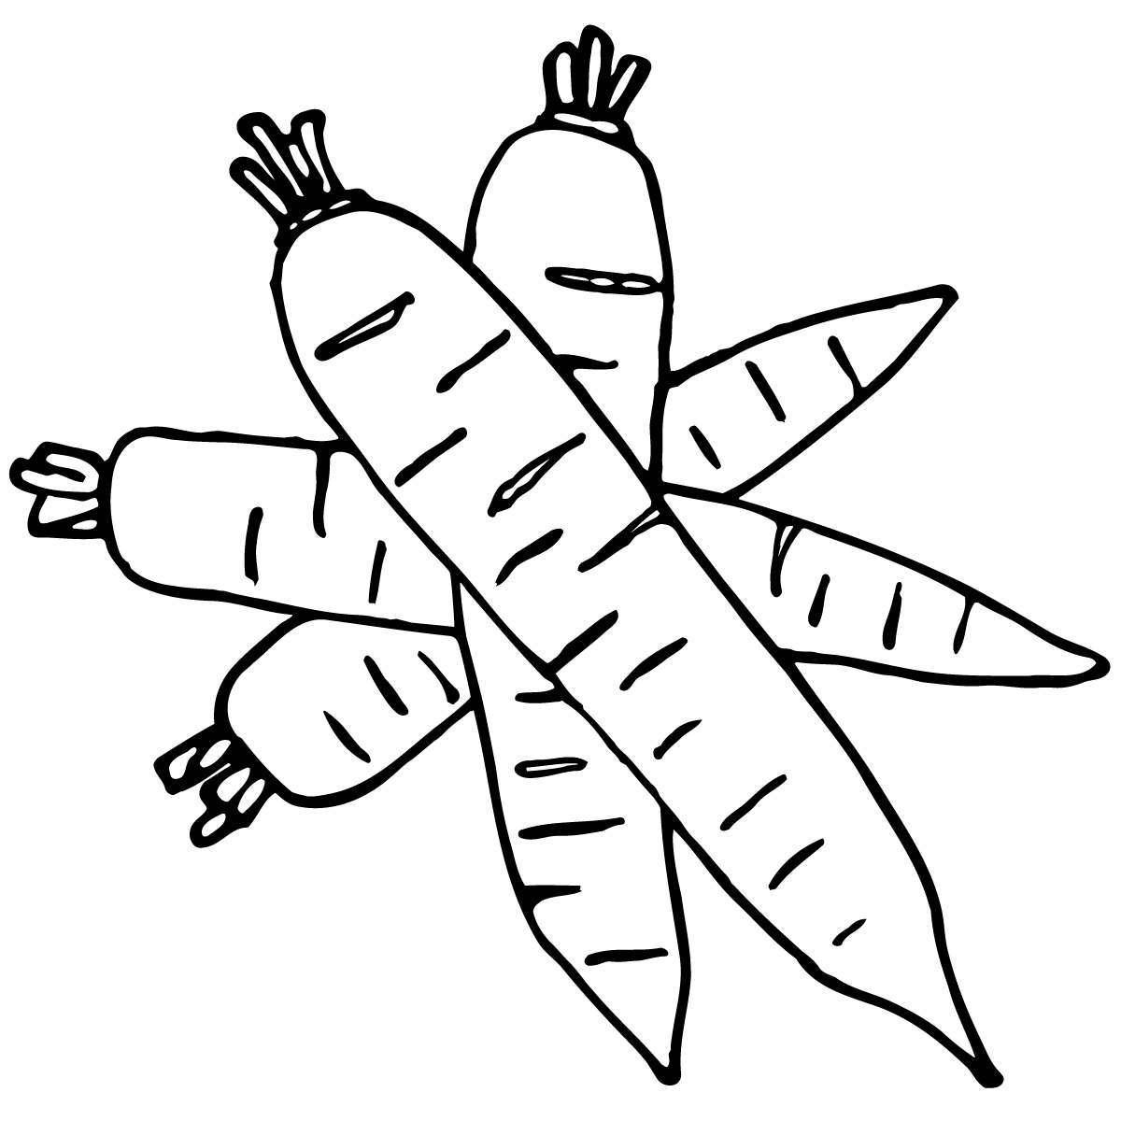

**Fitness & Health**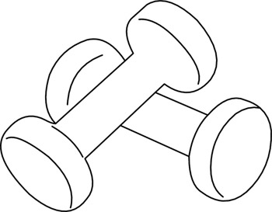

**Thai Cooking**

Learn to cook fresh, delicious Thai dishes in this class led by Terri Wilson, owner of *Mahli Thai Asian Cuisine* in Chippewa Falls. Classes are a combination of hands-on and demonstration where participants will enjoy creating and savoring the following: Shrimp & pork wonton dumpling, Red Curry Chicken lab (salad), Pad Thai, Mango Sticky Rice and more. Bring your appetite! *Please indicate class date choice on registration.

**Monday, October 24 (Cornell Elementary) 5:00-8:00pm**

**Monday, November 14 (Lake Holcombe School) 5:00-8:00pm**

**Fee: $30 per person Max: 10 students per class**

**Group Low Impact Fitness**

Low-impact workouts are typically easier on the body, especially our joints, and can be a great way to get in a heart-pumping workout while reducing the risk of injury. Plus, it keeps your heart healthy and lowers your risk of cardiovascular disease. The group setting makes for a great support system, too! Join this group fitness class that will use a variety of exercise videos led by Anne Bacon. **\*Pre-register by calling Magic Salons at (715) 595-6550\***

**Saturdays, starting Oct. 15 9:00-9:45am**

**Fee: $5 per class** (pay at class) **Magic Salons-Holcombe**

**Healthy Living Class**

Exercising and eating right are the first steps to improving your health.  Join Dr. Victoria VandeZande, with Prevea Health, for this free class offering tips on healthy eating, exercise, stress management, and sleep. Pre-registration is strongly recommended.

**Thursday, November 3 6:00-7:00pm**

**Fee: FREE Cornell Elementary School**

**Open Walking-Fitness Room**

The Cornell Elementary School gym and Lake Holcombe small gym are open for FREE walking exercise. Join fellow walkers in a safe, element-free environment.

This is a great way for post-op patients to build up endurance and a healthy way

to lose pounds sensibly for those who prefer a low-impact exercise regimen.

The fitness room at Lake Holcombe School is also available for community use

free of charge. Participants must sign in at the school office.

**Weekdays (Cornell Elem Gym) 8:00-9:00am**

**Weekdays (Lake Holcombe-small gym) 8:30-9:30am**

**Weekdays (Lake Holcombe Fitness Room) 7:00-10:00am & 6:00-9:00pm**



**Family**

**Parent & Child Playgroup**

Parents & caregivers are invited to bring children age birth to 3 yrs. to this new playgroup sponsored by River Source Family Center. Playgroup will meet the second and fourth Tuesday of each month (except Nov & Dec) and includes:

*Interactive Playtime *Healthy Snacks **Parent Connections

*Music & Story Time **1 free new book each month *Craft Activities

**Tues., Sept. 27, Oct. 11 & 25, Nov. 8, Dec. 13 9:00-10:30am**

**Fee: FREE Cornell Elementary**

**“Love and Logic”™ & FIRST**

Love and Logic changes lives. Practical skills parents can use immediately

bring the joy and fun back to parenting. This "how-to" approach is easy to

learn,effective, powerful, and lasting. Love and Logic has been helping

families prosper for over four decades. As we laugh together at ourselves

and the ups and downs of parenting, we will learn what it takes to raise

respectful, responsible kids who are fun to be around.

FIRST (Families Involved In Reaching Students Together) helps young

families adjust to the school setting. **Free child care is available**.

**(Fee is for all SIX SESSSIONS and includes one workbook, a $10 value)**

**Wednesdays, Oct. 12 thru Nov. 16 5:30-7:30pm**

**Fee: $30/family Cornell Elementary School**

**(Fee is for all SIX SESSSIONS and includes one workbook, a $10 value)**

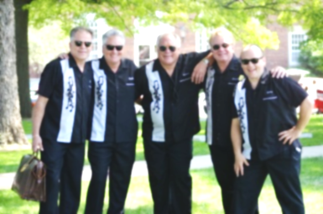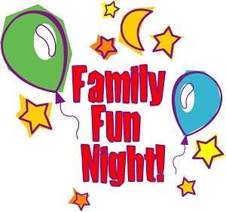

**Family Nights!**

Join us for some fun, hands-on activities the whole family can enjoy! Math, reading and science are incorporated into exciting activities where every family member is encouraged to dig in!

**PUMPKIN BOWLING Lake Holcombe School**

**Wednesday, October 26 5:30-6:30pm**

**POPCORN PARTY Cornell Elementary School**

**Wednesday, November 16 5:30-6:30pm**

**GINGERBREAD HOUSES Lake Holcombe School**

**Wednesday, December 7 5:30-6:30pm**

**FEE: $5/family per event After School Program Families-FREE!**

(Please indicate event name/date on registration form)



**Entertainment**

**The Clauson Family Music Show presents:**

**Christmas on the Farm** An afternoon of unforgettable entertainment awaits you at the **Clauson Family Music Show**. See a live Christmas show at the Historic Barn Theatre in Coloma, Wisconsin, and celebrate the season. Enjoy a delectable dinner, browse in the gift shop, pick up a treat from the Coffee Shoppe and then enjoy a spectacular show filled with great holiday music sure to put you in the Christmas spirit! Fee includes round-trip motorcoach transportation, scrumptious lunch, and music show admission. Lunch served at 12:30pm followed by show. Bus will stop at Culver’s in Rothschild for early dinner (on your own) and should return to Cornell approximately 6pm.

**Monday, December 5 Bus departs Cornell HS 9:00am**

**Fee: $75 per person Lunch-12:30pm followed by show**

**Adult Winter Dance Party**

**Featuring**

**The Whitesidewalls!**

**Sat., January 28, 2017**

**7:00-10:00pm**

**Cornell High School Gym**

**Tickets $22/advance $25/door**



“The Great Pretender”, “Charlie Brown”,

“Only The Lonely”…

just a sampling of the music you’ll rock and roll to during this night of fantastic entertainment by “the upper Midwest’s premier doo-wop, rockabilly, and rock and roll band”, The Whitesidewalls! Adults age 21 and older are invited to go back in time to the Golden Age of Rock N Roll! Concessions will be available during the dance including hot sandwiches, beverages, and treats. This is an alcohol-free event.

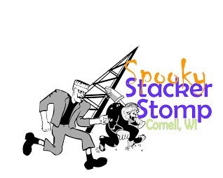

**Spooky Stacker Stomp-**

**5K Fun Run/Walk**

The spooky Stacker Stomp is a fun non-timed, interactive run/walk.  Participants are encouraged to show off their Halloween best with costumes.  Strollers and dogs on leashes are welcome.  Enjoy some Halloween fun for the whole family with music, raffles, refreshments, and photo opportunities with some friendly Halloween characters who will be roaming around the event area. Awards for the best individual and group costumes and medals for top female and male finishers (youth and adult) will be provided as well. Ghouls, Goblins, and Princesses welcome! This event is organized and sponsored by the Cornell Area Betterment Association along with the support of many area businesses and organizations. Proceeds benefit the “Save the Stacker” fund, the Cornell Food Pantry, and other local organizations.

To register go to <http://www.cornellwi.com/Resources>

**Saturday, October 8 Registration:  8:00am**

**Mill Yard Park, Cornell 100 Meter Kid's Dash: 9:00am**

**Stomp Start: 10:00am**

**Registration Fees**

**Day of race:**  
Individual Adults $30     Youth (16 & under) $15

After School Program information

* Students K-8 grade are eligible
* Keep Homework on Track
* Develop Friendships
* Try New Things
* Make Healthy Choices
* Transportation

Monday – Thursday right after school until 5:30pm

Request a registration packet from school to get signed up!

Fees are suggested but not required-

$10 per student registration

Sponsor a student/family for $50-200/year



**Safety**

**AARP Smart Driver Course**

AARP Driver Safety, which has helped older drivers stay safe, educated and confident behind the wheel since 1979, offer its research-based AARP Smart Driver course. After taking the course, you may be eligible for a multi-year discount on your car insurance! (Consult your auto insurance agent for details). Be one of the first to experience the new AARP Smart Driver course.

**Tuesday, November 1 9am-1pm**

**Fee: $15/AARP Member $20/non-member Lake Holcombe School**

Description: C:\Users\asmith\AppData\Local\Microsoft\Windows\Temporary Internet Files\Content.IE5\5WUV6GES\MC900133793[1].wmfDescription: C:\Users\asmith\AppData\Local\Microsoft\Windows\Temporary Internet Files\Content.IE5\5WUV6GES\MC900133793[1].wmf

**ATV Safety**

This course is designed to reduce the potential for ATV accidents, injuries and fatalities and emphasizes the importance of laws, ethics, personal safety and proper use. Anyone who operates an ATV on public riding areas who is at least age 12 years of age must have completed a safety certification course. For children under 12 years of age, the certificate does not become valid until the child reaches 12.

All students are required to obtain a WI DNR Customer ID Number before the completion of

this class and will also be required to provide that ID Number to the instructor. To obtain an ID

call the WI DNR Customer Service at 1-888-936-7463 or online at: [www.dnr.state.wi.us](http://www.dnr.state.wi.us).

**Please pre-register with Community Ed at least one week in advance!**

**Nov. 14, 15, & 17 4:30-7:30pm**

**Fee: $12**  **Cornell High School**

Description: C:\Users\asmith\AppData\Local\Microsoft\Windows\Temporary Internet Files\Content.IE5\5WUV6GES\MC900133793[1].wmfDescription: C:\Users\asmith\AppData\Local\Microsoft\Windows\Temporary Internet Files\Content.IE5\5WUV6GES\MC900133793[1].wmf**Snowmobile Safety**

This course is designed to reduce the potential for snowmobile accidents, injuries and fatalities and emphasizes the importance of laws, ethics, personal safety and proper use. Anyone who operates a snowmobile on public riding areas who is at least age 12 years of age must have completed a safety certification course. For children under 12 years of age, the certificate does not become valid until the child reaches 12.

All students are required to obtain a WI DNR Customer ID Number before the completion of

this class and will also be required to provide that ID Number to the instructor. To obtain an ID

call the WI DNR Customer Service at 1-888-936-7463 or online at: [www.dnr.state.wi.us](http://www.dnr.state.wi.us).

**Please pre-register with Community Ed at least one week in advance!**

**December 5, 7, & 8 4:30-7:30pm**

**Fee: $12 Lake Holcombe School**