Cornell & Lake Holcombe

 **Community**

 **Education**

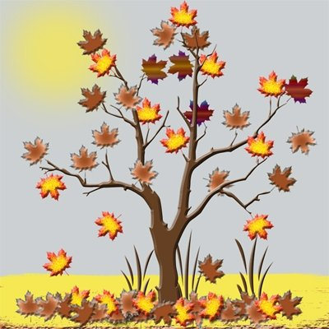

FALL 2015

CLASS OFFERINGS

**Brought to you by the 21st Century Community Learning Centers**

**of Cornell and Lake Holcombe**

**(715) 861-8011 or (715) 595-4241 x.249**

**www.communitylc.weebly.com**

**Welcome to the Cornell/Lake Holcombe**

**Community Education Fall 2015 Catalog. Enclosed within these pages is information about upcoming classes and community activities. Community Education is a cooperative venture between the Cornell/Lake Holcombe 21st Century CLC’s, the school districts, and the City of Cornell. It is committed to providing services and programs to meet community needs and residents’ interests. So, take time to look over the brochure, sign up and**

***ADD A LITTLE “CLASS” TO YOUR LIFE!***

**HOW TO REGISTER**

**Walk-In or Mail-In**

You may register in person Complete the Registration Form.

for all Community Ed classes *Make checks payable to:

by stopping by the  **Cornell / LH Community Ed**

Community Learning Center at *Mail Registration to:

Cornell Elementary School or **Community Education**

Lake Holcombe Schools **P.O. Box 517**

**Cornell, WI 54732**

**Please register at least 2 weeks prior to the start of the class.**

* No confirmation of registration will be sent.
* If class is cancelled because of low enrollment, you will be notified by phone and your money refunded.
* Once a class has begun, no refunds are permitted.
* Sorry, no refunds on trips.

**More info call: Andrea Smith, Community Programs Director at:**

**Cornell Office (715) 861-8011** [**asmith@cornell.k12.wi.us**](mailto:asmith@cornell.k12.wi.us)

**Lake Holcombe Office (715) 595-4241 ext. 249**

[**asmith@lakeholcombe.k12.wi.us**](mailto:asmith@lakeholcombe.k12.wi.us)

**Community Ed Registration Form**

**Name: ___________________________________________________________**

**Address: ________________________________________________________**

**Home Phone: ___________________ Cell Phone: _____________________**

**Email address: _______________________________________**

**C.E. Course Title(s):**

**1. _______________________________________________Fee: __________**

**2. _______________________________________________Fee: __________**

**3. _______________________________________________Fee: __________**

**Donate $5 or more to CLC Fund** (to help continue offering our programs) **__________**

**(Make checks payable to Cornell/LH Community Ed) Total: ____________**

**MAIL TO: Cornell/LH Community Ed P.O. Box 517 Cornell, WI 54732**

**Community Ed Registration Form**

**Name: ___________________________________________________________**

**Address: ________________________________________________________**

**Home Phone: ___________________ Cell Phone: _____________________**

**Email address: _______________________________________**

**C.E. Course Title(s):**

**1. _______________________________________________Fee: __________**

**2. _______________________________________________Fee: __________**

**3. _______________________________________________Fee: __________**

**Donate $5 or more to CLC Fund** (to help continue offering our programs) **__________**

**(Make checks payable to Cornell/LH Community Ed) Total: ____________**

**MAIL TO: Cornell/LH Community Ed P.O. Box 517 Cornell, WI 54732**

PAGE 1

Cornell & Lake Holcombe

** Community**

** Education**



FALL 2015

CLASS OFFERINGS

**Brought to you by the 21st Century Community Learning Centers**

**of Cornell and Lake Holcombe**

**(715) 861-8011 or (715) 595-4241 x.249**

**www.communitylc.weebly.com**

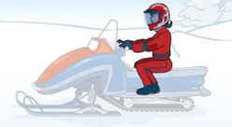**Snowmobile Safety**

*This DNR safety course consists of basic classroom instruction in the principles of snowmobile safety in order to expose new users to basic responsibilities, ethics, laws and mechanical functions. Any person who is born on or after*

*Jan. 1, 1985 and who has reached the age of 12, must have completed*

*and received a snowmobile safety certificate in order to operate a*

*snowmobile in Wisconsin. This does not apply to lands owned or*

*leased by the operator's parent or guardian. Anyone 10 years of age and*

*older is eligible to take this course and receive a safety certificate;*

*however the certificate does not become valid until the child reaches*

*12 years of age. All students are required to obtain a WI DNR Customer ID Number before the completion of this class and will also be required to provide that ID Number to the instructor.*

**Please pre-register with Community Ed at least one week in advance!**

**November 30, Dec. 2 & 3 4:00-7:00pm**

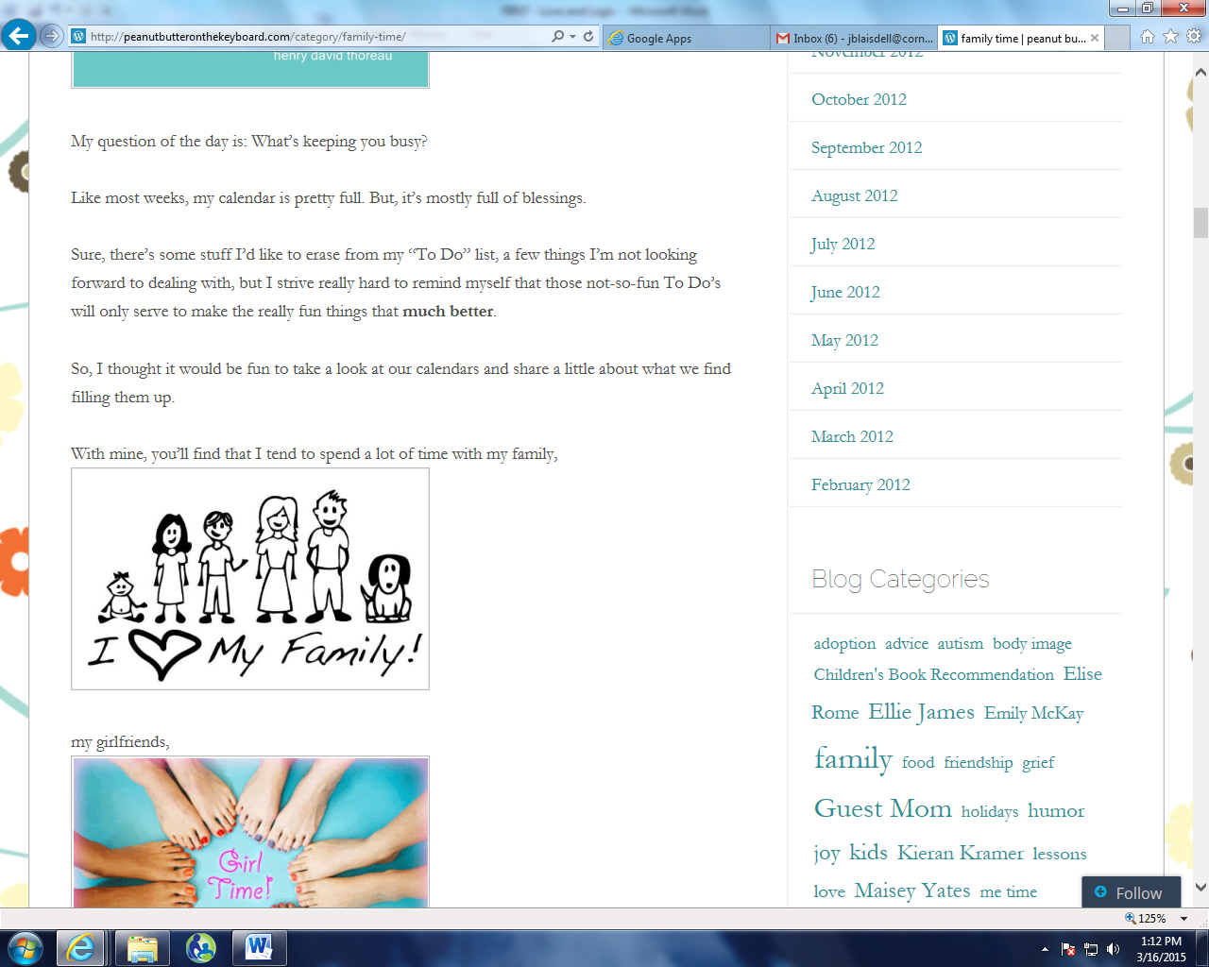**Fee: $12 Cornell H.S.**



**F I R S T**

*Since 1977 the Love and Logic Institute has been dedicated to making parenting and teaching fun and rewarding, instead of stressful and chaotic. They provide practical tools and techniques that help adults achieve respectful, healthy relationships with their children and help them prepare their kids for the real world. Love allows children to grow through their mistakes. Logic allows them to live with the consequences of their choices. This program is designed for all children but is most effective when initiated in the early years: PreK-Kindergarten age children.Join our local, Trained Independent Facilitator, Jenny Blaisdell, for this “first in*

*our area” Love and Logic™ Program. This special introductory price is a*

*one-time offer you won’t want to miss! The best part is that by participating*

*you’ll learn how to:*

* Put an end to arguing, back talk and begging
* Teach responsibility without losing their love
* Set limits without waging war
* Avoid power struggles
* Guide kids to own and solve their problems
* Teach kids to complete choirs without reminders and without pay

This program is designed to give you practical skills

PAGE 6

that can be used immediately!

**Mondays, beginning Oct. 5-Nov. 9 5:30-7:30pm**

**Fee: $50/couple $30/single Cornell Elementary**

(Fee is for all SIX SESSSIONS and includes one workbook, a $10 value)

Please register for ALL classes at least 2 weeks in advance!

PAGE 4

PAGE 3

**Swedish Weaving Table Runner**

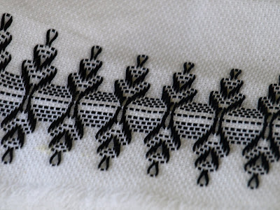Swedish weaving is a special form of decorative embroidery, also known as huck weaving. The designs are usually geometric in nature, and worked primarily along the surface of the cloth rather than going up and down through the cloth. It is usually done on a fabric known as monk's cloth. This fabric has a surface with raised threads that form squares-allowing designs to be symmetrical. A blunt needle is used to weave yarn or floss into beautiful patterns.  Instructor, Cathy Moussette, will guide you through the process of making your own table runner.  All materials will be furnished for this 4-session class.  Participants age 16+ welcome.  Please bring a pair of scissors to class.  Registration deadline: October 27.

**Mon & Wed, October 26, 28, Nov. 2, 4 6:00-8:00pm**

**Fee:  $25                                             Holcombe Home Ec Room**

PAGE 5

**oNGOING OPPORTUNITIES:**

**Camaraderie Club**

Area adults are invited to join us **every Monday** for a variety of activities in the warm atmosphere of Cornell Elementary School. Hobnob, meet new people, and enjoy social activities with your peers in a relaxed environment. A new activity will be offered each week including exercise, crafts, guest speakers, interactive games, and workshops. Bring your spouse, friend, neighbor, or come by yourself for some good times and camaraderie. No need to sign up…just show up!

**Mondays 9:00-11:00am Cornell Elementary School**

**Fee: FREE**

**Open Walking**

The Cornell Elementary School gym and Lake Holcombe “new” gym will be

open for walking exercise. Participants must wear tennis shoes and carry a

Community Ed pass, which is good on school days throughout the year.

Please register with Community Ed to obtain a walking pass and use Main

entrance at both buildings when walking.

**Mon thru Friday (Cornell Elem Gym) 8:00-9:00am**

**Mon thru Friday (Lake Holcombe) 8:30-9:30am**

**Sewing Group**

Enjoy a cup of coffee and some conversation while working on your sewing

project in the company of other crafters. Share ideas and watch the progress

MC900330922[1]of each project from week to week.

**Wednesdays 9:00-11:00am**

**Fee: FREE Cornell Elementary School**

**Zumba Gold**

Zumba Gold is designed for older adults who want to remain active or for those who are just beginning a fitness program. This is a low-impact class using Latin music and rhythms. Dance to great music, with great people, and burn a ton of calories! It's the perfect combo of fun and fitness. Be sure to bring water and wear comfortable shoes and clothing. Gym membership is not required to attend Zumba classes.

Note: Fees are payable directly to instructor, Kate Elling.

**Tuesdays** **4:30-5:30pm**

**Saturdays 8:30-9:30am**

**Fee: $5/class or $20/5 punch card Magic Salon, Holcombe**

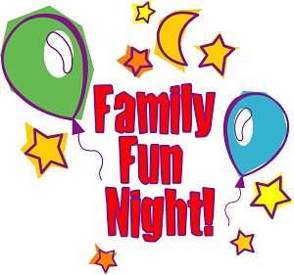 **Family Nights!**

Join us for some fun, hands-on activities the whole family can enjoy! Math, reading and science are incorporated into exciting activities where every family member is encouraged to dig in!

**POPCORN NIGHT Cornell Elementary School**

**Tuesday, September 29 5:30-6:30pm**

**PUMPKIN BOWLING Lake Holcombe School**

**Tuesday, October 28 5:30-6:30pm**

**SPAGHETTI RACES Cornell Elementary School**

**Tuesday, November 18 5:30-6:30pm**

**FEE: $10/family per event After School Program Families-FREE!**

(Please indicate event name/date on registration form)



**Babysitting Class**

PAGE 2

*This class will prepare you to be a safer and more responsible babysitter. Participants must be at least 11 years old. Material covered includes: basic infant and child care information, handling emergency situations, information to get from parents, and safety and accident prevention. A Baby-Sitters Handbook is provided to take home as well as a Certification of Completion.*

*This class is instructed by Katie Klein, R.N.*

**Monday, October 19 4:00-6:00pm**

**Fee: $10 Cornell Elem IMC**

Please register for ALL classes

at least 2 weeks in advance!

PAGE 8

PAGE 1

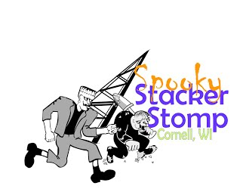**Spooky Stacker Stomp-**

**5K Fun Run/Walk**

*The spooky Stacker Stomp is a fun non-timed, interactive run/walk.  Participants are encouraged to show off their Halloween best with costumes.  Strollers and dogs on leashes are welcome.  Enjoy some Halloween fun for the whole family with music, raffles, refreshments, and photo opportunities with some friendly Halloween characters who will be roaming around the event area. Awards for the best individual and group costumes and medals for top female and male finishers (youth and adult) will be provided as well. Ghouls, Goblins, and Princesses welcome! This event is organized and sponsored by the*

*Cornell Area Betterment Association along with the support of many area businesses and organizations. Proceeds benefit the “Save the Stacker” fund, the Cornell Food Pantry, and other local organizations.*

To register go to <http://www.cornellwi.com/Resources>

**Saturday, October 10 Registration:  8:00am**

**Mill Yard Park, Cornell 100 Meter Kid's Dash: 9:00am**

**Stomp Start: 10:00am**

**Registration Fees**

**In Advance**:

Individual Adults $25  Youth (16 & under) $10

Team (6 or more) $20 ea.   Youth  $10 (16 & under)

**Day of race:**  
Individual Adults $30     Youth (16 & under) $15  
 Teams must be pre-registered by September 18, 2015

j0156091%5b1%5dATV Safety

*This course is designed to reduce the potential for ATV accidents, injuries and fatalities and emphasizes the importance of laws, ethics, personal safety and proper use. Anyone who operates an ATV on public riding areas who is at least age 12 years of age must have completed a safety certification course. For children under 12 years of age, the certificate does not become valid until the child reaches 12.*

*All students are required to obtain a WI DNR Customer ID Number before the completion of this class and will also be required to*

*provide that ID Number to the instructor. To obtain an ID*

*call the WI DNR Customer Service at 1-888-936-7463 or online at:* [*www.dnr.state.wi.us*](http://www.dnr.state.wi.us)*.*

**Please pre-register with Community Ed at least one week in advance!**

**October 26, 28, 29 4:00-7:00pm**

**Fee: $12**  **Cornell High School**

**QPR-Suicide Prevention Course**

*Do you know someone who might be at risk?*

*Question Persuade Refer*

Join us to learn the three steps anyone can take to help prevent suicide. Just like CPR, QPR is an emergency response to someone in crisis and can save lives. Learn to recognize the warning signs that someone may be thinking about suicide and how to help them. This course is free but space is limited.

**Please call (715) 717-4481 to register. Sponsored by HSHS Sacred Heart, St. Joseph’s 3D Community Health Plan**

**Wednesday, November 4 6:00-7:30pm**

**Fee: FREE (Doors open at 5:30pm) Holcombe Elem. IMC**

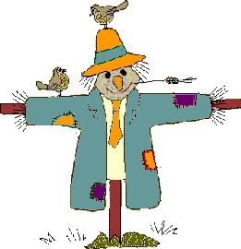

**Build A Scarecrow**

**Business & Family Activity/Contest**

*Gather up the family or your work crew and join us at Cornell Mill Yard Park to assemble a scarecrow to place in the garden or as a greeter to your front door.* ***Bring your own clothing*** *(large sizes work best- long pants, button-up long sleeve shirt, and any “extras” such as bandanas, hat, glove) and we’ll provide the rest! (max: 6 people per scarecrow/fee).Finished scarecrows will be displayed for judging in Cornell and at area businesses. Judging will take place October 2 with winners announced in both categories at the Spooky Stacker Stomp on Saturday, October 11.*

**Thursday, October 1 5:30-7:00pm**

**Fee: $10 per scarecrow Mill Yard Park**

**Family Finance Class**

**Pilates/Tai Chi**

**Whitesidewalls**

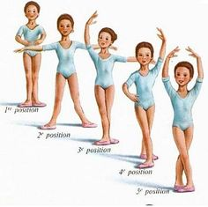

Beginners & Basic Ballet

Boys and girls ages 3-6 will learn basic ballet techniques in a healthy, nurturing, and fun way by instructors Stephanie Seidlitz and Jessica Hilger.  This 30 minute class will provide children the awareness of dance through creative movements and the joy of music. Girls will need ballet leotard and boys will need shorts and t-shirt; all kids will need ballet shoes. Children will showcase what they’ve learned during a spring dance recital.

**Mondays, beg. February 9 3:30-4:00pm (age 3-4) 4:00-4:30pm (age 5-6)**

**Fee: $22/month** (pay instructor) **Cornell Elementary School**

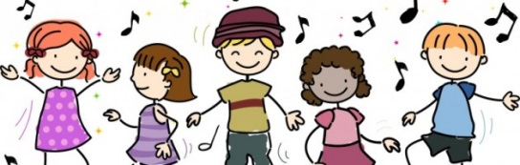

The World of Dance

This combination class for kids age 7-12 includes ballet, hip hop, jazz and modern dance instruction. It’s a great opportunity for children to express themselves through different dances that value the individual and creative process through fun and healthy movements. Girls will need a ballet leotard and boys will need shorts and t-shirt. Ballet shoes as well as athletic shoes are also required. Children will showcase what they’ve learned during a spring dance recital. Stephanie Seidlitz and Jessica Hilger instruct.

**Mondays, beginning February 9 5:00-6:00pm (age 7-12)**

**Fee: $32/month** (pay instructor) **Cornell Elementary School**

Creating a Silk Scarf

Create a gorgeous silk scarf using a variety of color hue dyes. Learn how to achieve different pattern and color effects and also have the opportunity to learn and apply a variety of techniques to achieve different textures. All students will complete and take home their creation after class. Two classes are offered

and will take place at instructor, Linda Bergen’s home.

**Wednesday, March 4 9am-noon or 1:00-4:00pm**

**Fee: $30 Linda Bergen’s Home**

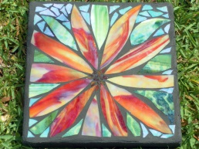

Mosaic Stepping Stones

Participants in this class will construct a gorgeous mosaic stepping stone using stained glass. We’ll learn to cut and grind glass, nip glass pieces, and adhere to a 12”x12” concrete base. All materials will be supplied by instructor, Linda Bergen, who will also grout and seal the finished project. Instructor has all the equipment needed and provides materials.

**Wednesday, May 20 9:00am-1:00pm**

**Fee: $45 Linda Bergen’s Home**