Nonprofit Org.

ECRWSS

U.S. POSTAGE

PAID

Permit No. 16

Cornell, WI

BOXHOLDER

HOLCOMBE

WISCONSIN 54745

P.O. Box 517

Cornell, WI 54732

Cornell & Lake Holcombe

**Community**

**Education**



SPRING 2017

OFFERINGS

**Compliments of the**

**Cornell & Lake Holcombe**

**21st Century Community Learning Centers**

**Access this brochure anytime, anywhere by visiting our website at** [**www.communitylc.weebly.com**](http://www.communitylc.weebly.com)

**Click on the Community Education tab**



**“Like” us on Facebook!**

**Welcome to the Cornell/Lake Holcombe**

**Community Education Spring 2017 Catalog. Enclosed within these pages is information about upcoming classes and community activities. Community Education is a cooperative venture between the Cornell/Lake Holcombe 21st Century CLC’s, the school districts, Rutledge Charities, and the City of Cornell. It is committed to providing services and programs to meet community needs and residents’ interests. So, take time to look over the brochure, sign up and**

***ADD A LITTLE “CLASS” TO YOUR LIFE!***

**Cornell & Lake Holcombe**

**21st Century Community Learning Centers**

**P.O. Box 517 Cornell, WI 54732**

**Find us on Facebook! **

**Check out our website!**

[**www.communitylc.weebly.com**](http://www.communitylc.weebly.com)

**HOW TO REGISTER**

**Walk-In or Mail-In**

You may register in person Complete the Registration Form.

for all Community Ed classes *Make checks payable to:

by stopping by the Community  **Cornell / LH Community Ed**

Learning Center at Cornell *Mail Registration to:

Elementary School or at **Community Education**

Lake Holcombe Schools **P.O. Box 517**

**Cornell, WI 54732**

**Please register at least 1 week prior to the start of the class.**

*No confirmation of registration will be sent. If class is cancelled because of low enrollment, you will be notified by phone and your money refunded. Once a class has begun, no refunds are permitted. Sorry, no refunds on trips.

**Need more info? Call Andrea Smith, Director**

**at (715)861-8011 or (715) 595-4241 ext. 249**

[**asmith@cornell.k12.wi.us**](mailto:asmith@cornell.k12.wi.us)

**Community Ed Registration Form**

**Name: ___________________________________________________________**

**Address: ________________________________________________________**

**Home Phone: ___________________ Cell Phone: _____________________**

**Email address: _______________________________________**

**C.E. Course Title(s):**

**1. _______________________________________________Fee: __________**

**2. _______________________________________________Fee: __________**

**3. _______________________________________________Fee: __________**

**___ Donate $5 to CLC Fund** (to help continue offering our programs) **__________**

**(Make checks payable to Cornell/LH Community Ed) Total: ____________**

**Mail to: P.O. Box 517 Cornell, WI 54732**

**Community Ed Registration Form**

**Name: ___________________________________________________________**

**Address: ________________________________________________________**

**Home Phone: ___________________ Cell Phone: _____________________**

**Email address: _______________________________________**

**C.E. Course Title(s):**

**1. _______________________________________________Fee: __________**

**2. _______________________________________________Fee: __________**

**3. _______________________________________________Fee: __________**

**___ Donate $5 to CLC Fund** (to help continue offering our programs) **__________**

**(Make checks payable to Cornell/LH Community Ed) Total: ____________**

**Mail to: P.O. Box 517 Cornell, WI 54732**

Special Event-Save the Date!



**Crafts**

**Adirondack-style Backpack Basket**

This basket is made to be used! It has skids on the bottom to make it stand sturdy. Prior weaving skills are a must for this two-night class instructed by Shirley Mount, owner of the Basket Patch in Gilman. Two sizes: Large (17”w x 13” d x 19”h) or, Medium (14”w x 9”d x 14”h). Price of class does not include harness. Please include harness fee with registration form if interested (Large=$25 beige only; Medium=$18 green only). **Supplies to bring to class: Bucket, spray bottle, towel, clip clothes pins, pencil, tape measure, scissors, flat screwdriver.**

**Mon & Tues, March 27 & 28 5:00-9:00pm**

**Fee: Large=$80 Med=$70 Cornell Elementary School**

**Barn Quilts (On A Smaller Scale)**

Enjoy creating your own “home sized” barn quilt! Participants in this class will create a 24”x24” quilt square suitable for hanging on a garage, shed, or house. The pattern will be transferred to a primed plywood square and then painted with your choice of colors. Once completed, instructor, Linda Bergen will seal the projects. Limit 6 participants. **Please bring a hair dryer to help dry the coats of paint.**

**Wednesday, March 29 9:00am-1:00pm (or longer)**

**Fee: $35 Linda Bergen’s Home**

**It’s A Wrap**

Learn the techniques of wrapping, winding, and sewing narrow strips of fabric into a bowl shape to create a beautiful bowl. Simply wrap the fabric strips around clothesline, coil into shape, and secure with machine stitching. All materials provided by instructor, Linda Bergen.

**Wednesday, April 5 9:00am-3:00pm**

**Fee: $16 Linda Bergen’s Home**

**Garden Quilts** (on a stepping stone)

Do you like barn quilts but have no place for one? Create a beautiful 12”x12” “garden size” concrete quilt square using a variety of patterns and stained glass. All materials included. Linda Bergen, instructor, will grout and seal the finished project.

**Wednesday, April 19 9:00am-1:00pm**

**Fee: $45 Linda Bergen’s Home**

**Mosaic Stepping Stones**

Construct a gorgeous mosaic stepping stone using stained glass. We’ll learn to cut and grind glass, nip glass pieces, and adhere to a 12”x12” concrete base. All materials will be supplied by instructor, Linda Bergen, who will also grout and seal the finished project. All materials are provided.

**Wednesday, May 24 9:00am-1:00pm**

**Fee: $45 Linda Bergen’s Home**



**Fitness & Health**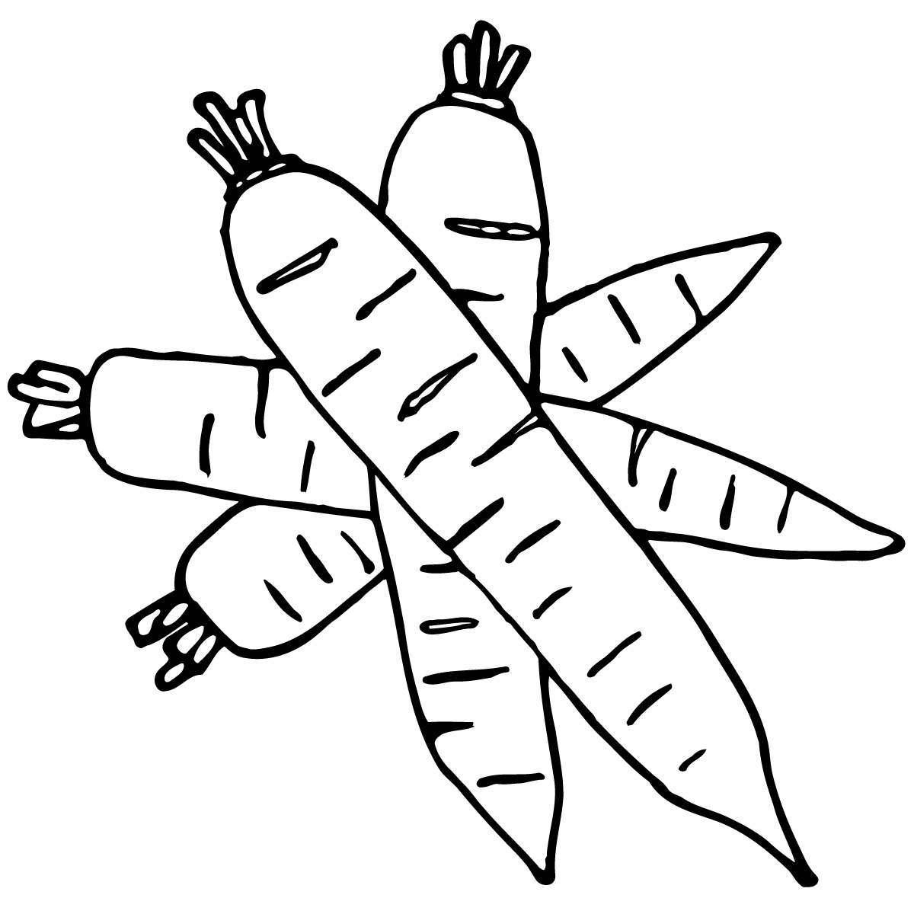

**Dance!**

Boys and girls ages 3-12 are invited to this energetic class instructed by Stephanie Seidlitz and Jessica Hilger. Dancers will discover fun and skill development through movement, music, learning and laughter. We will explore a variety of different dances and showcase our skills at a dance recital in April on Friday, April 28.

**Wednesdays, March 1, 8, 15 ,22 ,29 Cornell Elem. Gym**

**April 5, 12, 19**

**3-5yr old $25 per month   4:30-5pm**

**6-8 yr old $25 per month   5:15-5:45pm**

**9-12 yr old $35 per month  6:00-6:30pm**

**Open Walking-Fitness Room**

The Cornell Elementary School gym and Lake Holcombe small gym are open for FREE walking exercise. Join fellow walkers in a safe,

element-free environment. This is a great way for post-op patients to build up endurance and a healthy way to lose pounds sensibly for those who prefer a low-impact exercise regimen. The fitness room at Lake Holcombe School is also available for community use free of charge.

Participants must sign in at the school office.

**Weekdays (Cornell Elem Gym) 8:00-9:00am**

**Weekdays (Holcombe-small gym) 8:30-9:30am**

**Weekdays (Holcombe Fitness Room) 7-10am & 6-9pm**

**Friends of Community Ed Highlight**

**Cornell American Legion Post 353**

**Chartered Organization for Cub Scouts Pack 2**

The Helge Grotte Scout Building in Cornell was recently demolished because it was beyond repair. American Legion Post 353, Pack 2 Cub Scouts, and Cornell Girl Scouts intend to replace it with a new building that will be low-maintenance but will still provide storage space, a bathroom, and a picnic shelter that can be used by local scouting groups (boys and girls). It will also serve as an “outdoor classroom” that will provide more opportunities to utilize the surrounding property and a park-like setting for the community. Future plans for the property include a garden, native plantings, benches, and more!! We hope to begin work in the spring of 2017.

**Pack 2 Cub Scouts and the Cornell Girl Scouts serve about 55 boys and girls from the Cornell and Holcombe communities.**

Help preserve the Scouting Tradition in our communities and provide opportunities for local children to develop into future leaders and active community members. Donations of $100 or more will be recognized on a donor wall at the new building. Donate $2,500 or more to sponsor a picnic table. Sponsoring a picnic table is a wonderful way to memorialize or honor a loved one, display your family name or business, or to commemorate your memories of scouting! Sponsored picnic tables will display a plaque or engraving with your name.  

They have a goal of raising $30,000. Scouting families, Cornell American Legion members, Tim Bach Construction, and other friends have pledged their time to cover the majority of the labor.

For more information, please contact

Scott Bowe, Cub Master, Pack 2 Cub Scouts, [**715-239-6789**](tel:(715)%20239-6789)

*Follow****Pack 2 Cub Scouts****on Facebook!*

____________________________________________________________________

I would like to donate:

__________ $2,500+ Eagle Scout level (picnic table)

 __________ $1,000 - $2,500 Arrow of Light level

__________  $500 - $1,000 Cub Scout level

 __________ $100 - $500 Bobcat level

__________ Other

Please make checks payable to:   **American Legion Post 353**

**PO Box 71**

**Cornell, WI 54732**

Name as you would like it to appear on the donor wall:

_______________________________________________



**Safety**

Description: C:\Users\asmith\AppData\Local\Microsoft\Windows\Temporary Internet Files\Content.IE5\5WUV6GES\MC900133793[1].wmfDescription: C:\Users\asmith\AppData\Local\Microsoft\Windows\Temporary Internet Files\Content.IE5\5WUV6GES\MC900133793[1].wmf

**Babysitting Course**

This class will prepare you to be a safe and responsible babysitter. Participants must be at least 11 years old. Material covered includes:

basic infant and child care information, handling emergency situations, information to get from parents, and safety and accident prevention.

A Baby-Sitters Handbook is provided to take home as well as a

Certificate of Completion. This class is instructed by Jeanne Walsh,

UW Extension Family Living Agent.

**Monday, March 6 4:00-5:30pm**

**Fee: $10 Holcombe Elem. IMC**

**Boater Safety**

Beginning boaters and experienced experts alike need to be familiar

with boating safety rules of operation. A person who is at least 12 years

old may operate a PWC only if he or she has completed a boating safety course accepted by Wisconsin Department of Natural Resources. It's always important to be educated and prepared for every circumstance

that might arise. This DNR safety course is offered to anyone 10 years

of age and older, however, the safety certificate does not become valid

until 12 years of age.

**March 27, 28 & 30 4:30-7:30pm**

**Fee: $12 Lake Holcombe School**

**Bike Rodeo/Glow Ride**

This event was so much fun last year that we’re bringing it back again! Load up the bikes and the family and join us at Mill Yard Park in Cornell. This free event features an obstacle course, helmet fitting, road safety information, and door prizes. We’ll conclude with an awesome activity:

A glow ride at dusk! Everyone will receive a few free glow sticks to be secured to your bike or your body. Bring additional glow sticks and

really light things up! We’ll then round everyone up for a glow ride

from Mill Yard Park to the office at Brunet Island State Park and back.

**Friday, May 19 8:00-8:30pm Activities**

**Fee: FREE 8:30-9:00pm Glow Ride**

**Cornell Mill Yard Park**



**Technology**

Description: C:\Users\asmith\AppData\Local\Microsoft\Windows\Temporary Internet Files\Content.IE5\5WUV6GES\MC900133793[1].wmfDescription: C:\Users\asmith\AppData\Local\Microsoft\Windows\Temporary Internet Files\Content.IE5\5WUV6GES\MC900133793[1].wmf**Technology in the Classroom**

Parents, have you ever wondered about the latest way your child is

Being taught using technology? When they mention a “Smartboard” or “Chromebook”, do you know what they are referring to? Join us for a

“tour” where you become the student and learn the ins and outs of

how technology is used in the classroom. Included will be hands-on experimenting and question/answer session led by Pat Talbot.

**Thursday, March 16 6:00-7:30pm**

**Fee: FREE Lake Holcombe School**

**Computer Basics for the Adult Learner**

If you’re one of the many adults who have little or no computer experience, we invite you to join us for this slow-paced technology-teaching opportunity. Classes will focus on how to operate a computer, create documents, manage files, use the internet, and create gmail accounts. This class will be very flexible and modified to meet the needs of the participants. Adults age 18+ only. Pat Talbot instructs the Holcombe class and Nicole Modl will be leading the Cornell class. Sign up for one or both locations!

**Tues & Thurs, March 21, 23, 28, 30 6:00-7:30pm**

**Fee: $5/session $17/all 4 sessions Holcombe-HS Computer Lab**

**Mon & Wed, Mar 13, 15, 20, 22, 27, 29 6:00-7:30pm**

**Fee: $5/session  $25/6 sessions           Cornell-Elem. Computer Lab**

Thank You!

**Community Education has a strong history in our communities. As our way of saying “thanks” for participating, we will put your name in a drawing for a $25 Gordy’s gift card when you include this coupon with your registration form for any of the classes listed in this brochure.**

Limit one entry per person. Registration must be received on or before

March 31, 2017 drawing. Winner will be notified by phone.

Name: __________________ Phone #____________

**Sewing Group**

Are you new to sewing? Do you want to spend time with others doing

what you love? A sewing group could be the perfect place for you.

Enjoy a cup of coffee and some conversation while working on your

sewing projects in the company of other crafters.

**Wednesdays 9:00-11:00am**

**Fee: FREE Cornell Elementary School**

**Family**

**Parent & Child Playgroup**

Parents & caregivers are invited to bring children age birth to 3 yrs. to this playgroup sponsored by River Source Family Center. Playgroup will meet the second and fourth Tuesday of each month (except April 11) and includes:

*Interactive Playtime *Healthy Snacks **Parent Connections

*Music & Story Time **1 free new book each month *Craft Activities

**Tues., Feb. 28, Mar 14, 28, Apr. 25, May 9, 23 9:00-10:30am**

**Fee: FREE Cornell Elementary**

**Mother & Son Dance**

Boys, it’s time to ask your favorite girl to a dance! Dress up and invite

your favorite lady (Mom, Grandma, Aunt, etc.) to dance the night away. Every couple will be treated to ice cream sundaes and refreshments,

and receive a 5x7 souvenir photo to keep as a memory of a great night

out together. Moms receive a tiara and boys get a crown.

Boys age 3-13 welcome; chaperones must be at least 18 years old.

**Friday, March 31 5:30-7:30pm**

**Fee: $10/couple Cornell Elementary Gym**

$5 for each additional boy; limit 3 children per adult

MCj03978400000[1]

**Save The Date**

**OUTDOOR “ED-VENTURE”**

**Sunday, April 30 11am-2pm**

Cornell Mill Yard Park

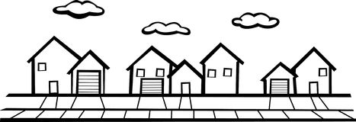

**Community**

**The Beauty of Hospice and Palliative Care**

What do you know about hospice or palliative care? If you have a

loved one in or approaching long term care, care for someone at

home, or work in a long term care facility, this information can help

you be prepared to make difficult decisions to provide the best care

for yourself or someone else. Talk with others who have “been there.”

Cynthia Bednar, RN, Mayo Home Health and Hospice will present.

**Tuesday, February 28 5:00pm**

**Fee: FREE Cornell Area Care Center**

**Property Owner’s Guide to Emerald Ash Borer**

Since being discovered in 2002, the emerald ash borer (EAB) has killed tens of millions of trees in the U.S., including in Wisconsin. When a tree is severely infected, treatment may not be effective as it may be too compromised to save. That is why it is highly recommended that property owners utilize preventative methods in at-risk areas like Cornell and Lake Holcombe. Learn more about the EAB and methods/treatments used to save your ash trees before the EAB strikes. This information session will be presented by Tree Savvy Tree Service of Eleva, and UW-Extension Chippewa Co., Crops and Soils Educator, Jerry Clark.

**Wednesday, March 22 6:00-7:00pm**

**Fee: FREE Cornell Elementary School**

**Camaraderie Club**

The name says it all! This very friendly and active group of adults meets every Monday morning for coffee, conversation and camaraderie! Something new is offered each week including information on hot topics, craft activities, guest speakers, games, and cards. Small fees may be required for special events. Join us anytime…no membership required!

**Mondays 9:00-11:00am**

**Fee: FREE Cornell Elementary School**

**4thAnnual**

March 14, 2017 Parent University Registration

Please return this portion to school by 3/9/17

**Family Name: _________________________ Phone # ______________**

**Email address: _______________________________________________**

|  |  |  |
| --- | --- | --- |
| Your Name = Your Choices | | **Each adult signs up for 2 workshops!** |
| Name | Name | **Love and Logic:** Ever felt like you’re sinking under the current of parenting? Let’s dive into the ocean of raising great kids and grab a life ring called “Love and Logic.” |
| Name | Name | **Careful and Kind Online:** Get ready for an interactive discussion on Social Media. We challenge our students to carefully use technology for good and make an impact. |
| Name | Name | **Dollars During Development:** Discuss reading aloud to your children, and using financial literacy stories to help kids learn about saving money and budgeting. |
| Name | Name | **School in 2017:** Want a peek into your kids’ life? Technology has changed some things in the classroom, but you might be surprised by what’s stayed the same. |

**____Total # of Children Attending: ____PreK & under**

**____Grades K-3 ____Grades 4-8**

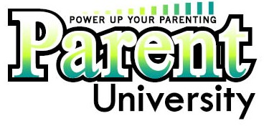

**Tuesday**

**March 14, 2017**

**Lake Holcombe School**

**5:15-8:00 PM**

**AGENDA:**

**5:15-5:45 FREE dinner for the whole family**

**5:50-6:30 Parent Workshops / Kids Activities**

**6:30-7:10 Parent Workshops / Kids Activities**

**7:10-8:00 Totally Turtles by: Snake Discovery *Free Child Care for age 0-3 years\***

